Employee Attrition Analysis
Data Analytics Project
Prepared by: Varun Kaushik
Department: Computer Science and Engineering
Institution: Gokaraju Lailavathi Engineering College
Tools Used: Python, Pandas, Matplotlib, Seaborn, Tableau
Project Overview
Employee attrition refers to the situation where employees leave an organization voluntarily or involuntarily. High employee attrition can affect productivity, recruitment costs, employee morale, and organizational performance.
This project analyzes an HR Employee Attrition dataset to identify patterns and factors associated with employee turnover. The analysis uses Python for data cleaning and exploratory data analysis and Tableau for interactive visualization.
The objective is to understand which employee segments show higher observed attrition and to provide data-driven insights that can help HR teams investigate potential retention challenges.
Objectives
The main objectives of this project are:
- To understand the structure and characteristics of the HR dataset.
- To identify and handle data quality issues.
- To analyse overall employee attrition.
- To study attrition across different employee segments.
- To examine the relationship between attrition and factors such as overtime, salary, age, job role, job satisfaction, and work-life balance.
- To identify important patterns through exploratory data analysis.
- To create an interactive Tableau dashboard.
- To provide business insights and recommendations based on the analysis.

Dataset Overview
Dataset Description
The dataset contains employee-level HR information including demographic details, job-related information, compensation, satisfaction levels, working experience, and attrition status.

The dataset contains:
Attribute | Value
Total Employees | 1,470
Total Columns | 35
Employees Who Left | 237
Employees Who Stayed | 1,233
Overall Attrition Rate | 16.12%
Average Age | 36.92 years
Average Monthly Income | 6,502.93
The target variable for this analysis is Attrition, which has two categories:
- Yes – Employee left the organization
- No – Employee stayed in the organization
Data Types
The dataset contains both:
Numerical variables
- Age
- DailyRate
- DistanceFromHome
- HourlyRate
- MonthlyIncome
- MonthlyRate
- TotalWorkingYears
- YearsAtCompany
- YearsInCurrentRole
- YearsSinceLastPromotion
- YearsWithCurrManager
Categorical variables
- Attrition
- BusinessTravel
- Department
- EducationField
- Gender
- JobRole
- MaritalStatus
- OverTime
There are also ordinal/rating variables such as JobSatisfaction, EnvironmentSatisfaction and WorkLifeBalance.

Data Cleaning
Missing Values
The dataset was checked for missing and null values using Pandas.
Result: No missing values were found in the dataset.
Therefore, no imputation or deletion of records was required.

Duplicate Records
The dataset was checked for duplicate rows.
Result: No duplicate records were found.
Therefore, all 1,470 employee records were retained.

Constant Columns
The following columns contained the same value for every employee:
- EmployeeCount
- Over18
- StandardHours
Since these columns do not provide useful variation for analysis, they were removed.

Employee Identifier
EmployeeNumber is a unique employee identifier rather than an analytical feature. It was therefore removed from the analysis dataset. After removing these unnecessary columns, the dataset contained 31 analytical columns.

Data Validation
Logical validation was also performed on employee experience-related fields.
For example, YearsAtCompany should not be greater than TotalWorkingYears.
The validation found 0 invalid records, indicating that these fields were logically consistent.
Exploratory Data Analysis
Overall Attrition
The dataset contains 1,470 employees, of whom 237 left the organization and 1,233 remained.
The overall attrition rate is: 16.12%
This provides the baseline against which different employee segments were compared.

Attrition by Department
The observed attrition rates were:
Department | Attrition Rate
Sales | 20.63%
Human Resources | 19.05%
Research & Development | 13.84%
Sales had the highest observed attrition rate among the three departments, while Research & Development had the lowest. This indicates that attrition patterns vary across departments and may require department-specific investigation.

Attrition by Overtime
Overtime showed a substantial difference in observed attrition.
Overtime | Attrition Rate
Yes | 30.53%
No | 10.44%
Employees who reported working overtime had a considerably higher observed attrition rate than employees who did not. This suggests that workload and overtime patterns should be examined when investigating employee retention.

Attrition by Salary Group
Employees were divided into salary groups based on monthly income.
Salary Group | Attrition Rate
Low | 29.27%
Medium | 14.21%
High | 10.63%
Very High | 10.33%
The low-salary group had the highest observed attrition rate.
The difference suggests that compensation level and salary progression may be relevant factors to investigate when studying employee turnover.

Attrition by Age Group
Age Group | Attrition Rate
≤25 | 35.77%
26–35 | 19.14%
36–45 | 9.19%
46+ | 12.45%
Employees aged 25 or below had the highest observed attrition rate at 35.77%, while employees aged 36–45 had the lowest at 9.19%. This indicates that attrition patterns vary across age groups, with relatively higher observed attrition among younger employees.

Attrition by Job Role
Significant differences were observed across job roles.
Job Role | Attrition Rate
Sales Representative | 39.76%
Laboratory Technician | 23.94%
Human Resources | 23.08%
Sales Executive | 17.48%
Research Scientist | 16.10%
Manufacturing Director | 6.90%
Healthcare Representative | 6.87%
Manager | 4.90%
Research Director | 2.50%
Sales Representatives had the highest observed attrition rate, while Research Directors had the lowest. However, differences in group sizes should also be considered when interpreting these percentages.

Attrition by Business Travel
Business Travel | Attrition Rate
Travel Frequently | 24.91%
Travel Rarely | 14.96%
Non-Travel | 8.00%
Employees who travelled frequently showed a higher observed attrition rate compared with employees who travelled rarely or did not travel. This suggests that travel requirements may be worth investigating alongside workload and job demands.
Attrition by Job Satisfaction
Job Satisfaction | Attrition Rate
1 | 22.84%
2 | 16.43%
3 | 16.52%
4 | 11.33%
Employees with the lowest job satisfaction score had a higher observed attrition rate than employees with the highest satisfaction score. The pattern is generally consistent with lower satisfaction being associated with greater attrition, although the middle categories are not perfectly monotonic.

Attrition by Work-Life Balance
Work-Life Balance | Attrition Rate
1 | 31.25%
2 | 16.86%
3 | 14.22%
4 | 17.65%
Employees with the lowest work-life balance rating had the highest observed attrition rate. However, the relationship is not perfectly linear because the highest rating does not have the lowest attrition rate.

Interaction Analysis
Individual variables provide useful information, but analyzing combinations of variables can reveal additional patterns.
Age and Overtime
Among employees aged 25 or below:
- Without overtime: 22.62% attrition
- With overtime: 64.10% attrition
Among employees aged 26–35:
- Without overtime: 12.08%
- With overtime: 38.99%
This shows that overtime is associated with higher observed attrition across age groups, with a particularly high rate observed among the youngest group.
Salary and Overtime
For the low-salary group:
- Without overtime: 17.49%
- With overtime: 58.49%
For the medium-salary group:
- Without overtime: 10.00%
- With overtime: 26.04%
The combination of lower salary and overtime shows a particularly high observed attrition rate. This segment may therefore be useful for targeted HR investigation.

Key Business Insights
Insight 1 — Overall Attrition
The organization has an overall observed attrition rate of 16.12%, with 237 out of 1,470 employees leaving. This provides a baseline for comparing different employee segments.
Insight 2 — Overtime and Attrition
Employees working overtime had an observed attrition rate of 30.53%, compared with 10.44% for employees who did not work overtime. This indicates a strong association between overtime and employee attrition within this dataset.
Insight 3 — Higher Attrition Among Younger Employees
Employees aged 25 or below had an observed attrition rate of 35.77%, substantially higher than the 9.19% observed among employees aged 36–45. This suggests that early-career employees may require greater attention to onboarding, career development and retention.

Insight 4 — Salary Differences
The low-salary group had an observed attrition rate of 29.27%, compared with 10.33% for the very-high-salary group. This indicates that compensation level is associated with differences in observed attrition.
Insight 5 — Job Role Differences
Attrition varies considerably by job role. Sales Representatives had an observed attrition rate of 39.76%, while Research Directors had 2.50%. This suggests that retention challenges may differ significantly depending on job responsibilities and role characteristics.
Insight 6 — Combined Risk Patterns
The combination of overtime with younger age or lower salary shows particularly high observed attrition. For example, employees aged 25 or below who worked overtime had an observed attrition rate of 64.10%.
Similarly, employees in the low-salary group who worked overtime had an observed attrition rate of 58.49%. These findings can help identify segments for further HR investigation.
Insight 7 — Satisfaction and Work-Life Balance
Lower job satisfaction and lower work-life balance ratings generally correspond with higher observed attrition. However, these relationships are not perfectly linear, so they should be interpreted as patterns rather than direct causal relationships.

Recommendations
1. Review Overtime and Workload
HR teams can review overtime requirements, workload distribution and staffing levels in departments or roles with high overtime exposure.
2. Strengthen Early-Career Retention
Since younger employees show higher observed attrition, organizations could strengthen:
- Employee onboarding
- Mentorship programs
- Career development
- Training opportunities
- Early-career progression plans
3. Review Compensation and Salary Progression
The higher attrition observed among lower-salary employees suggests that compensation competitiveness and salary progression should be reviewed, particularly for employees with high workload requirements.

4. Develop Role-Specific Retention Strategies
Since attrition varies considerably across job roles, a single retention strategy may not be suitable for all employees. HR teams can investigate the specific workload, career progression, compensation and working conditions associated with high-attrition roles.
5. Focus on High-Risk Combinations
Employees exposed to combinations such as young age + overtime or low salary + overtime could be prioritized for further investigation. These groups should not automatically be assumed to be at risk of leaving; rather, they represent segments with higher observed attrition in this dataset.
6. Monitor Employee Satisfaction
Regular employee engagement and satisfaction surveys can help identify changes in employee sentiment and potential retention issues.

Tableau Dashboard
An interactive Tableau dashboard was created to provide a visual summary of employee attrition patterns.
The dashboard contains KPI cards showing:
- Total Employees
- Employees Who Left
- Attrition Rate
- Average Monthly Income
- Average Age
It also contains visualizations analyzing attrition by:
- Department
- Overtime
- Salary Group
- Age Group
- Job Role
- Business Travel
- Job Satisfaction
- Work-Life Balance
The dashboard enables users to compare employee segments and identify areas with relatively higher observed attrition.

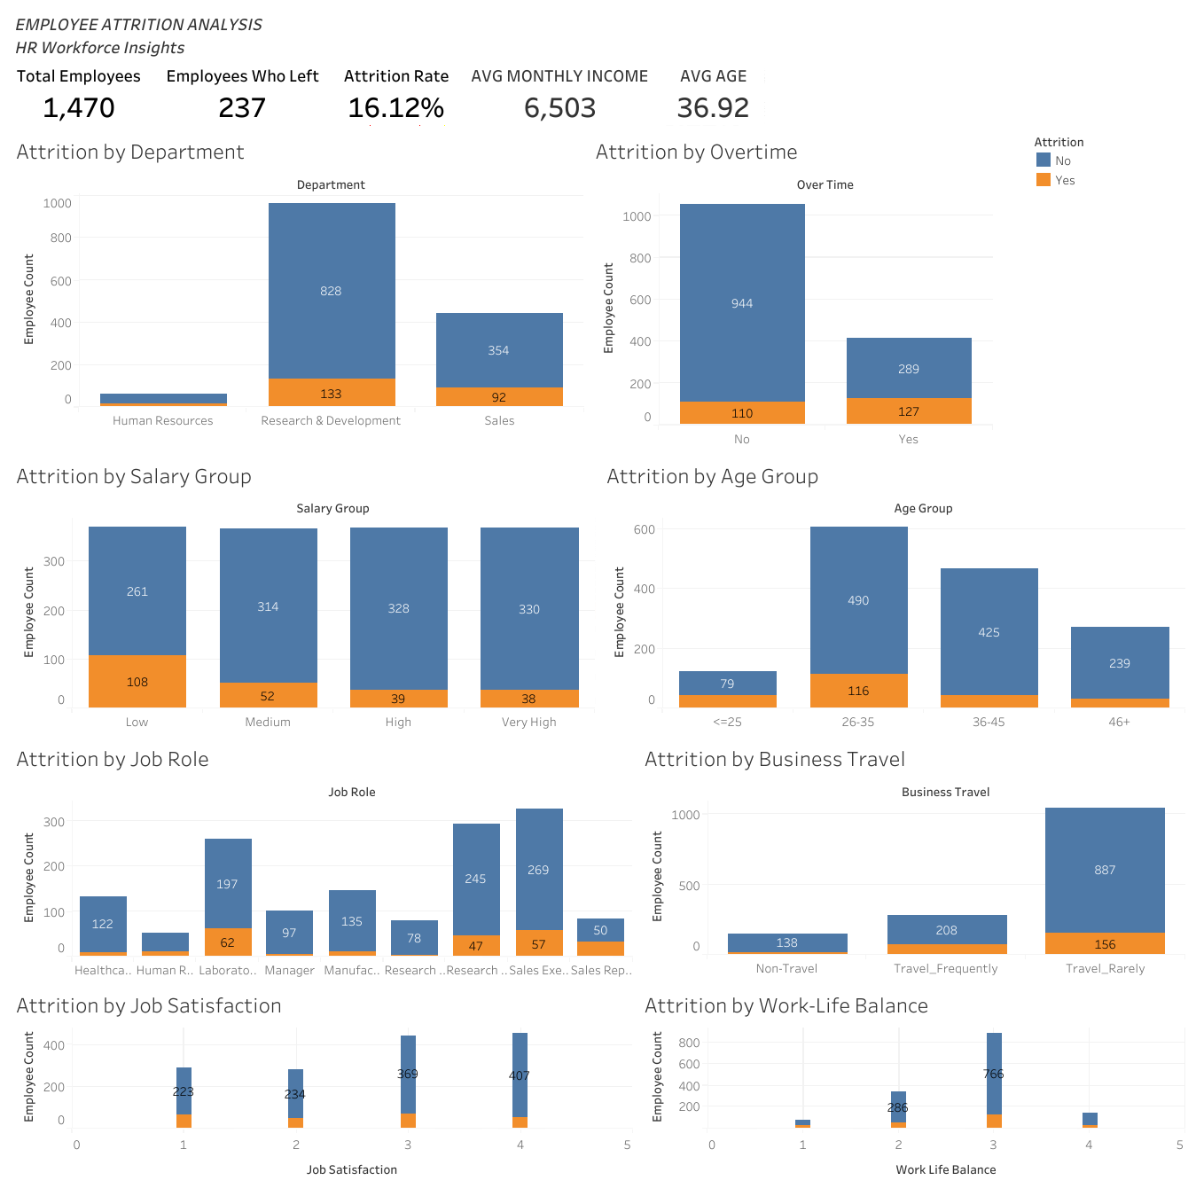

Interactive Tableau Dashboard:
Click here to explore the dashboard with interactive charts and hover tooltips.

Limitations
The analysis has several limitations:
- The dataset represents a specific HR dataset and may not represent all organizations or industries.
- The analysis identifies associations and patterns, not causal relationships.
- Some employee segments contain fewer observations than others, which can make percentages more sensitive to individual records.
- The analysis is based on the variables available in the dataset.
- Additional information such as employee interviews, reasons for leaving, organizational culture and longitudinal employment history could provide deeper understanding.
- Further statistical analysis or predictive modeling would be required to estimate individual attrition risk.
Conclusion
This project analyzed employee attrition using Python-based data cleaning and exploratory data analysis, followed by an interactive Tableau dashboard.
The analysis found noticeable differences in observed attrition across overtime status, age groups, salary groups, departments, job roles, business travel, job satisfaction and work-life balance.
Overtime, younger age, lower salary and certain job roles were associated with higher observed attrition rates in the dataset. Interaction analysis also highlighted particularly high observed attrition among some combinations of employee characteristics.
The findings can help HR teams identify areas for further investigation and develop targeted employee-retention strategies. However, the results should be interpreted as data-driven associations rather than proof of causation.

